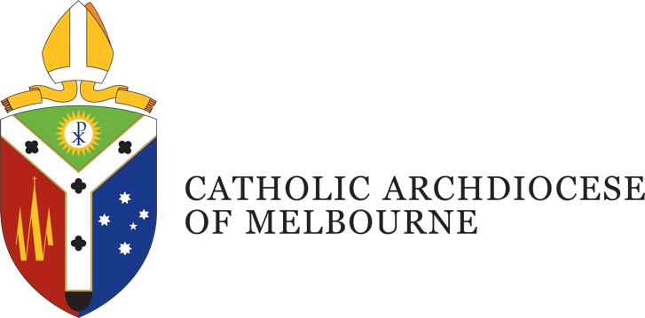

Position Description
Title: Events Coordinator
Department: Development and Philanthropy Office
Location: St Patrick’s Centre, East Melbourne
Employment Status: Permanent, full time
Reports to: Development Operations Manager
Number of direct reports: nil

Position Purpose
The Archdiocese of Melbourne is Australia’s largest diocese, hosting and managing a wide range of events, functions, and conferences each year.
The Events Coordinator plays a central role in the coordination and delivery of these major Archdiocesan engagements, serving as the primary point of contact for their planning and execution.
As part of the Development and Philanthropy Office, this role works closely with key internal stakeholders. including Proclaim: Office of Mission Renewal, the Office of the Archbishop, and the Stewardship Office, to support the Archdiocesan events calendar, ensuring that all major events are thoughtfully planned, well-resourced, effectively managed, and seamlessly coordinated.

Department Overview
The Development and Philanthropy Office of the Archdiocese of Melbourne was instituted by the Archbishop of Melbourne in 2022. The purpose of the department is to develop programs and foster relationships within the Catholic Community to support:
- Initiatives of the Archbishop of Melbourne
- The Parishes of the Archdiocese
- Catholic Agencies of the Archdiocese
The program calls upon the deep tradition of the Church and its theology to inform its approach to the various fundraising activities.

Organisational Description
Presided over by the Archbishop of Melbourne, the Archdiocese comprises around 1.1 million Catholics, and is the largest Archdiocese in Australia with a wide variety of people, cultures and ministries, providing services and support including pastoral, educational, social welfare and administrative support.
Under the guidance of four key priorities outlined by the Archbishop, the works and activities of the Archdiocese are oriented towards a missionary focus to address the ongoing needs of: Local Communities; Families; Youth and Young Adults; and the Poor and the Broken.
This is achieved through a pro-active engagement in the sharing of Mission; a reaching out in Gospel boldness; operating in an agile and responsive mindset; identifying and embracing what is fruit bearing in our works; understanding the outward focus and call of being missionary disciples; and being mindful of good stewarding in terms of time, talent and gifts.

Key Accountabilities
- Engage with internal stakeholders in the early planning stages to clarify objectives, determine priorities, and gather requirements for upcoming Archdiocesan events, functions, and conferences.
- Assist with coordination of Archdiocesan functions and events, working closely with internal stakeholders to drive project planning, risk management, budgeting, sponsorship, and promotional strategies from concept to delivery.
- Maintain internal systems and databases including online booking platforms, electronic direct mail systems, video conferencing tools, and other event management technologies.
- Manage the Archdiocesan events and functions calendar, ensuring accurate diary management, scheduling, and coordination in collaboration with key stakeholders.
- Collaborate with a range of external stakeholders—including venues, caterers, audio-visual providers, and other event suppliers—to ensure the seamless delivery of high-quality Archdiocesan events and functions, negotiating services, managing logistics, and fostering positive working relationships.
- Act as a liaison between agencies to ensure events and functions run in accordance with the mission of the Archdiocese as well as supporting agencies in regard to planning and protocols - especially those that involve Bishops, VIP & Dignitaries, Council or Government Stakeholders
- The Archdiocese may require you to undertake other duties from time to time commensurate with your qualifications, knowledge, experience and ability.
- Takes reasonable care to protect the health and safety of themselves, fellow staff and others in the workplace.

Job Competencies – (skills)
- Intermediate to advanced skills in Microsoft Office Suite – especially Excel
- Excellent project management skills
- High level interpersonal skills including the ability to engage with and establish strong working relationships with the community, other organisations, and internal teams
- Well-developed time management skills, with an ability to meet deadlines
- Knowledge in risk management and compliance procedures.
- National Police record and Working with Children Checks (essential).

Personal Competencies – (attributes)
- High level of integrity, honesty, and confidentiality, with an awareness and appreciation of Catholic Social Teaching.
- Willingness to work in accordance with the mission, ethos, and teachings of the Catholic Church.
- Excellent interpersonal, verbal and written communication skills.
- Ability to work collaboratively within and across departments, agencies, ministries and parishes of the Catholic Archdiocese of Melbourne and its partners.

Key Selection Criteria
- Proven experience in successfully planning, coordinating, and delivering multiple events simultaneously in a dynamic environment
- Strong interpersonal, organisational, and communication skills.
- Commitment to the mission and values of the Catholic Church.
- High level of attention to detail, quality, and accuracy.

Position Description Acknowledgement
By signing my contract, I acknowledge that I have received, reviewed and fully understand the position description for Click or tap here to enter text. I further understand that I am responsible for the satisfactory execution of the essential functions described therein, under any and all conditions as described.

Employee Name: Click or tap here to enter text. Date: Click or tap to enter a date.

Employee Signature: _________________________________________

