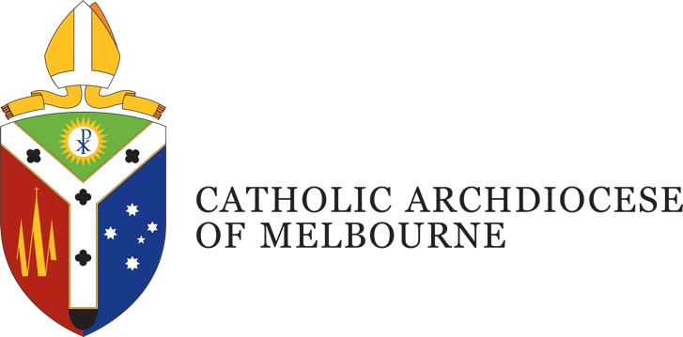

Position Description
Title: Archives Administration Assistant
Department: Archives, Office of the Archbishop
Location: East Melbourne
Employment Status: Permanent, full time
Reports to: Archivist and Museum Manager

Position Purpose
The Archives Administrative Assistant plays a key support role within the Archives team of the Catholic Archdiocese of Melbourne. This role assists with the cataloguing, organisation, and retrieval of ecclesiastical, business, and historical records, and supports the day-to-day operations of the archives and museum. Under the direction of the Archivist and Museum Manager, the Archives Assistant provides essential administrative and technical support in the maintenance of archival records, facilitates public and internal research requests, and assists with exhibitions, public events, and publications. This role contributes to the long-term preservation of the Church’s patrimony and supports broader access to its rich historical record.

Department Overview
The Archives Department of the Catholic Archdiocese of Melbourne plays a vital role in preserving, managing and promoting the historical and cultural patrimony of the Church in Melbourne. Functioning as a key part of the Office of the Archbishop, the department operates with the oversight of the Chancellor of the Archdiocese, who holds canonical responsibility for the Church’s archival records.
The department is responsible for the care and custodianship of ecclesiastical, business, and historical records that reflect the Archdiocese’s rich spiritual, administrative and community life. This includes the Archdiocesan Archives, which safeguard vital canonical and governance documentation, and the Archdiocesan Museum, which houses artefacts and memorabilia of liturgical, cultural, and historical significance.
Informed by the guidelines of the Pontifical Commission for the Cultural Heritage of the Church, the brief of the Archdiocese Archive and Museum is to collect historical material and memorabilia concerning the patrimony of the Church, to ensure that it is appropriately housed, to provide public display of the material, to make it accessible for the public, for schools and for researchers, and to publish an historical journal, Footprints, which the Archivist manages.

Organisational Description
Presided over by the Archbishop of Melbourne, the Archdiocese comprises around 1.1 million Catholics, and is the largest Archdiocese in Australia with a wide variety of people, cultures and ministries, providing services and support including pastoral, educational, social welfare and administrative support.
Under the guidance of four key priorities outlined by the Archbishop, the works and activities of the Archdiocese are oriented towards a missionary focus to address the ongoing needs of: Local Communities; Families; Youth and Young Adults; and the Poor and the Broken.
This is achieved through a pro-active engagement in the sharing of Mission; a reaching out in Gospel boldness; operating in an agile and responsive mindset; identifying and embracing what is fruit bearing in our works; understanding the outward focus and call of being missionary disciples; and being mindful of good stewarding in terms of time, talent and gifts.

Key Accountabilities
- Assist in the maintenance and administration of the Archdiocesan archival management systems and databases.
- Enter and maintain Series-level records for ecclesiastical, business, and historical documents.
- Support the Archivist in the search and retrieval of records for internal stakeholders and members of the public.
- Assist with management of school groups and visitors to the Museum and Cathedral exhibitions.
- Provide administrative and distribution support for the publication of Footprints and related material.
- Support the setup of archival displays for events, exhibitions, and regular public viewing spaces.
- Respond to basic research enquiries and facilitate access to approved archival material.
- Participate in special projects as directed, including digitisation and collection care initiatives.
- The Archdiocese may require you to undertake other duties from time to time commensurate with your qualifications, knowledge, experience and ability.
- Takes reasonable care to protect the health and safety of themselves, fellow staff and others in the workplace.

Job Competencies – (skills)
- Tertiary qualification in archives, records, information management, or a related field.
- Eligibility for full membership of the Australian Society of Archivists is desirable.
- Experience in an archival or museum setting is desirable.
- Ability to handle archival and historical materials with precision, ensuring accuracy in data entry, metadata capture, and file management.
- Proficiency in using archival description software and an understanding of strategies for managing born digital records.
- Skilled in Microsoft Office and general administrative systems.
- Capable of drafting clear correspondence, assisting researchers, and documenting workflows with professionalism and clarity.
- Well-developed issue management and problem solving skills
- National Police record and Working with Children Checks (essential) and a current driver's licence (desirable).

Personal Competencies – (attributes)
- High level of integrity, honesty and confidentiality, with an awareness and appreciation of Catholic Social Teaching.
- High level of attention to detail, accuracy, and organisation.
- Sound time-management skills and ability to prioritise.
- Demonstrated interpersonal skills, with the ability to work cooperatively.
- Commitment to confidentiality and professionalism in the management of sensitive Church records.
- Interest in Church history and a motivation to support the mission and values of the Catholic Church.
- Excellent interpersonal, verbal and written communication skills.
- Ability to work collaboratively within and across departments, agencies, ministries and parishes of the Catholic Archdiocese of Melbourne and its partners.

Key Selection Criteria
To be considered for the position of Archives Administrative Assistant, applicants must address the following Key Selection Criteria in their application:
- Degree qualified in archives, records information management or related field, or equivalent work experience.
- Demonstrated interest in archives, history, or cultural heritage, with a commitment to supporting the mission of the Catholic Church.
- Strong organisational and administrative skills, with attention to detail and a methodical approach to task management.
- Proficiency in Microsoft Office and a willingness to learn archival and records management systems.
- Strong interpersonal and written communication skills, with the ability to engage respectfully with a variety of stakeholders.
- Ability to work independently and collaboratively within a small, mission-oriented team.
- Experience in an administrative, customer service, or records-based role (experience in an archival or museum setting is desirable).
- A current Working with Children Check or the ability to obtain one.

Position Description Acknowledgement
By signing my contract, I acknowledge that I have received, reviewed and fully understand the position description for Archives Administration Assistant. I further understand that I am responsible for the satisfactory execution of the essential functions described therein, under any and all conditions as described.

Employee Name: Click or tap here to enter text. Date: Click or tap to enter a date.

Employee Signature: _________________________________________

