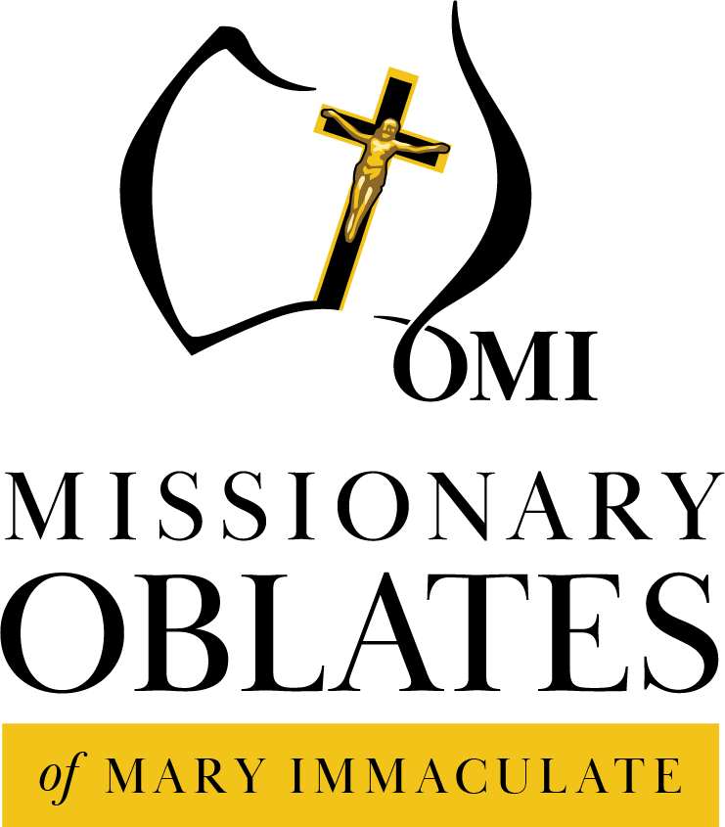

Missionary Association of Mary Immaculate –
MAMI Officer
(0.6 FTE)

Employment Information Kit

NOVEMBER 2022
Introduction

Oblates of Mary Immaculate
The Congregation of the Missionary Oblates of Mary Immaculate was founded by Saint Eugene de Mazenod.
St Eugene was described by his contemporaries as a man who had "a heart as big as the world". The impact of the French Revolution, coupled with a profound experience of the love of God, led him to dedicate his life to the service of Jesus Christ and the Church. By founding the Missionary Oblates of Mary Immaculate in Southern France in 1816, Eugene sought to embody and communicate the Gospel of Christ to an increasingly diverse and secular world.
At his death in 1861, there were 400 Oblates working in Europe, Asia, Africa and America. Today, almost 4,000 Oblate priests and brothers, along with lay associates, work in 67 countries, on every continent.
His life of virtue was recognized by the Church and, on 3 December 1995, Pope John Paul II declared him a Saint.
The Oblates arrived in Western Australia in 1894, taking charge of Fremantle parish and a reform school. The Oblates moved from the west coast of Australia to the eastern coast thirty two years later. Their house in the isolated and poor parish of Sorrento became a launching pad for an explosion of missionary activity. Through parish missions and retreats, the Oblates became known throughout Australia.
Oblates are currently working in a variety of ministries in parishes, secondary colleges, formation, and specific chaplaincies to the homeless, prisons, hospitals and youth.
More information – www.omi.com.au
Safeguarding Commitment Statement

The Oblates of Mary Immaculate (OMI) hold the care, safety and well-being of children and vulnerable adults as a central and fundamental responsibility of our organisation. Children and vulnerable adults have a right to be safe and we commit to ensure and protect these rights in all Oblate ministries. We commit to policies and processes which reduce the likelihood of harm and respond appropriately to disclosures and allegations. We commit to providing the necessary resources to ensure compliance with all relevant child protection laws, regulations and the National Catholic Safeguarding Standards and to maintaining a child-safe culture.

Oblate Ministries

The Oblates aim to nurture existing networks and develop new networks between ministries in the Australian Province. These include but are not limited to the Missionary Association of Mary Immaculate (MAMI), Partners in Mission (PIMs), the De Mazenod Family, Oblate Youth Australia (OYA), Rosies Mission Victoria and Rosies Queensland, Oblate Parish and School ministries.

The De Mazenod Family is a developing lay ministry in the Australian Province. The term “De Mazenod Family” refers to all those who identify with the charism of St Eugene de Mazenod and the Congregation he founded.

The De Mazenod Family team is in its early stages of developing networks across Oblate ministries to work closely with Oblates and laity to name, celebrate and participate in mutual formation in our common charism.

The Missionary Association of Mary Immaculate (MAMI) is one organisation through which the Oblates enlist the help of lay people. Through this Association, lay people become part of our Oblate Family. They become our co-workers, co-helpers and Oblate Associates. Members receive a certificate on being enrolled and they also receive a copy of our Oblate Newsletter – the MAMI News Bulletin. We offer Mass each day for all our members and they are also remembered in our Community prayers. Through this important ministry, money is raised to support the missions overseas, particularly in Indonesia and China, as well as the important ministry of formation.

Partners in Mission (PIMs) is a program of the Australian Province of the Oblates of Mary Immaculate which offers members of the Oblate Family the opportunity to work as part of an overseas Oblate Mission community, and to develop their own faith by helping others and living in community as lay missionaries.
The program commenced in 2009 in the Oblate Mission in Zhaoqing, in Guangdong Province in south eastern China. The PIMs Program may also be extended to Oblate missions in Java and Kenya in the future.

Oblate Youth Australia is a national community of young people who identify with the Oblates of Mary Immaculate, who come together in a spirit of fun and friendship to help build community by sharing their Catholic faith and life experiences. Oblate Youth Australia provides resources for local weekly meetings and organizes local and national events.

Rosies Mission
Named in honor of its humble beginnings in 1975, Rosies began as a summer outreach of young people to young people in Rosebud, Vic. In 1991 it was decided that a similar service could be provided to those who were isolated and homeless in the city of Melbourne, so Rosies moved to its present home, Flinders Street in Victoria and then expanded into Brisbane.

Oblate Parishes
Since their arrival in Australia in 1894, the Missionary Oblates of Mary Immaculate have served the Australian Church through the pastoral care of parishes. Beginning with the Fremantle parish in Western Australia and expanding across the country, the Oblates now care for nine parishes in WA, SA, Vic, NSW and Qld. Through their parish ministry, the Oblates are able to enact an essential part of their mission, which is to preach the Good News of Jesus Christ. Additionally, parish work brings our Oblates into contact with many different kinds of people, young and old. Parishioners from our Oblate parishes form an essential part of our De Mazenod Family.

Oblate Colleges
The Australian Province of the Missionary Oblates of Mary Immaculate has a proud tradition of meeting the needs of young people through contact with them in our Parishes, Colleges, Rosies and other youth ministries. The Oblates originally came to Australia to fulfil an educational role. The great influx of migrants after WWII had placed overwhelming pressures on the Catholic education system and in the mid-1950s the Missionary Oblates of Mary Immaculate received many invitations to open schools in various dioceses throughout Australia.

There are now 3 Oblate boys' colleges in Australia, with Iona College in Queensland, and Mazenod College in both Victoria and Western Australia, as well as St Eugene’s College, a co-educational school in Queensland.
Position Description

Position titles: MAMI Officer

Reports to: Provincial & MAMI Director

Purpose of the position:
The MAMI Officer fulfills a multi-faceted role, which will work primarily within the Oblate Provincial House Offices coordinating and communicating with ministries of the whole Australian Oblate Province and international Missionary works. The purpose of the MAMI Officer is to work as the liaison between the members of the Association, the Director and Australian Oblate Province, so as to maintain and further the membership of the Association thereby to financially support and aid the building of our communities and the work of our ministries.

Preferred qualifications & skills:
- A strong commitment to and understanding of the mission, teachings and practices of the Catholic faith.
- Knowledge of or capacity to learn about the history and mission of the Oblates in Australia and their charism.
- Clear and fluent written and verbal communication skills.
- A ‘Pastoral’ approach to communications - verbal and written. Good listening skills and caring telephone manner.
- IT skills with knowledge of Online Database systems, Microsoft Office and Email.
- Interpersonal and team-work skills.
- Highly organised and able to work independently.
- A high level of energy, a spirit of generosity and an ability to work to deadlines.
- Valid current driver’s licence.
- Valid Victorian Working with Children Check

Key Accountabilities and Responsibilities:
- The coordination and management of the MAMI office.
- Data entry and management of the iMIS online data system.
- Collecting, sorting and actioning of mail received.
- Banking of donations - both electronic and physical.
- Communication with Donors by telephone, email or letter.
- Assisting the publication of the MAMI newsletter.
- Maintenance of Registers.
- Organisation of Appeals - Annual and Parish
- Coordination with Oblate ministries and Oblate parishes with their various needs, as they arise.
- Other duties as requested.
This position is based in Melbourne. The position will require the successful applicant to work 4 days a week for 6 hours per day, primarily in the Camberwell Office. There is some flexibility with regards to times and days.

The successful applicant will require a Police Check and a Working with Children Check and will need to comply with the Oblates’ Safeguarding Commitment in line with Catholic Professional Standards Ltd, available at https://omi.com.au/child-vulnerable-people-safe-standards

Remuneration: Remuneration subject to experience and qualifications
1 Year Contract; 24 Hour week
A Work Computer will be provided.
Please send applications to Fr Christian Fini via email only cfini@oblates.com.au
By 6th December 2022

