13th Annual PLA
26th ANNUAL MELBOURNE EASTER PASSION PLAY
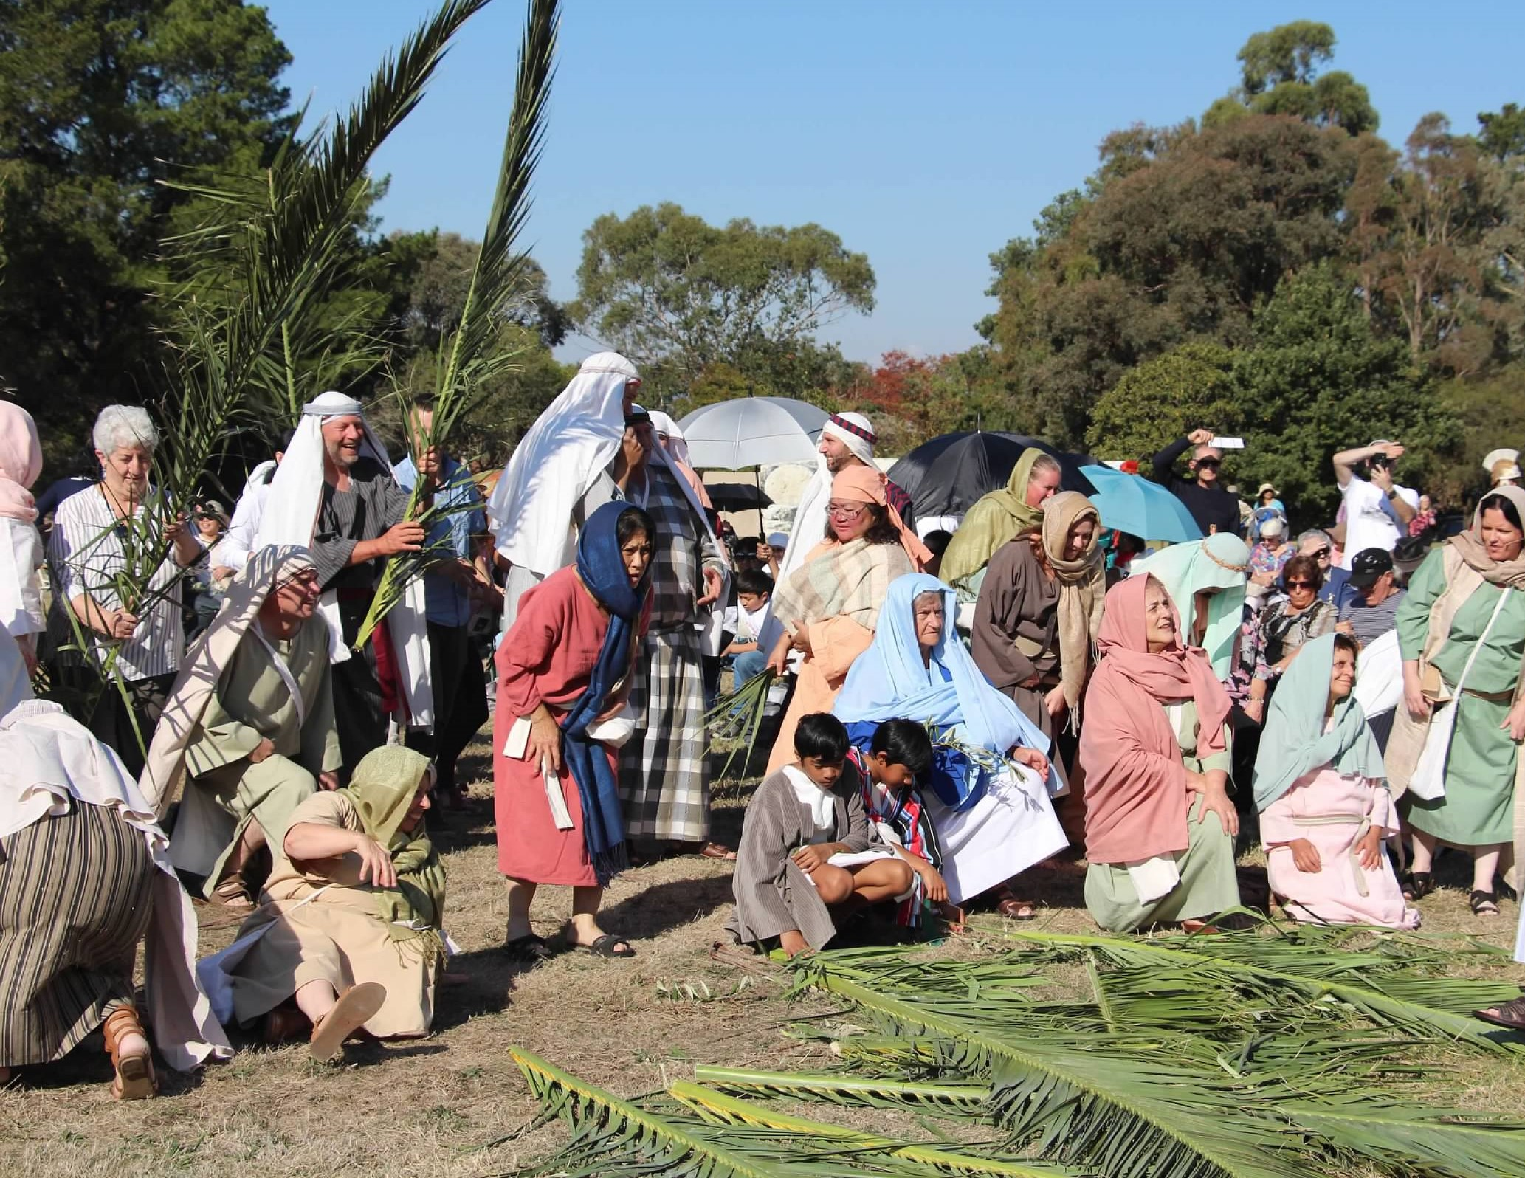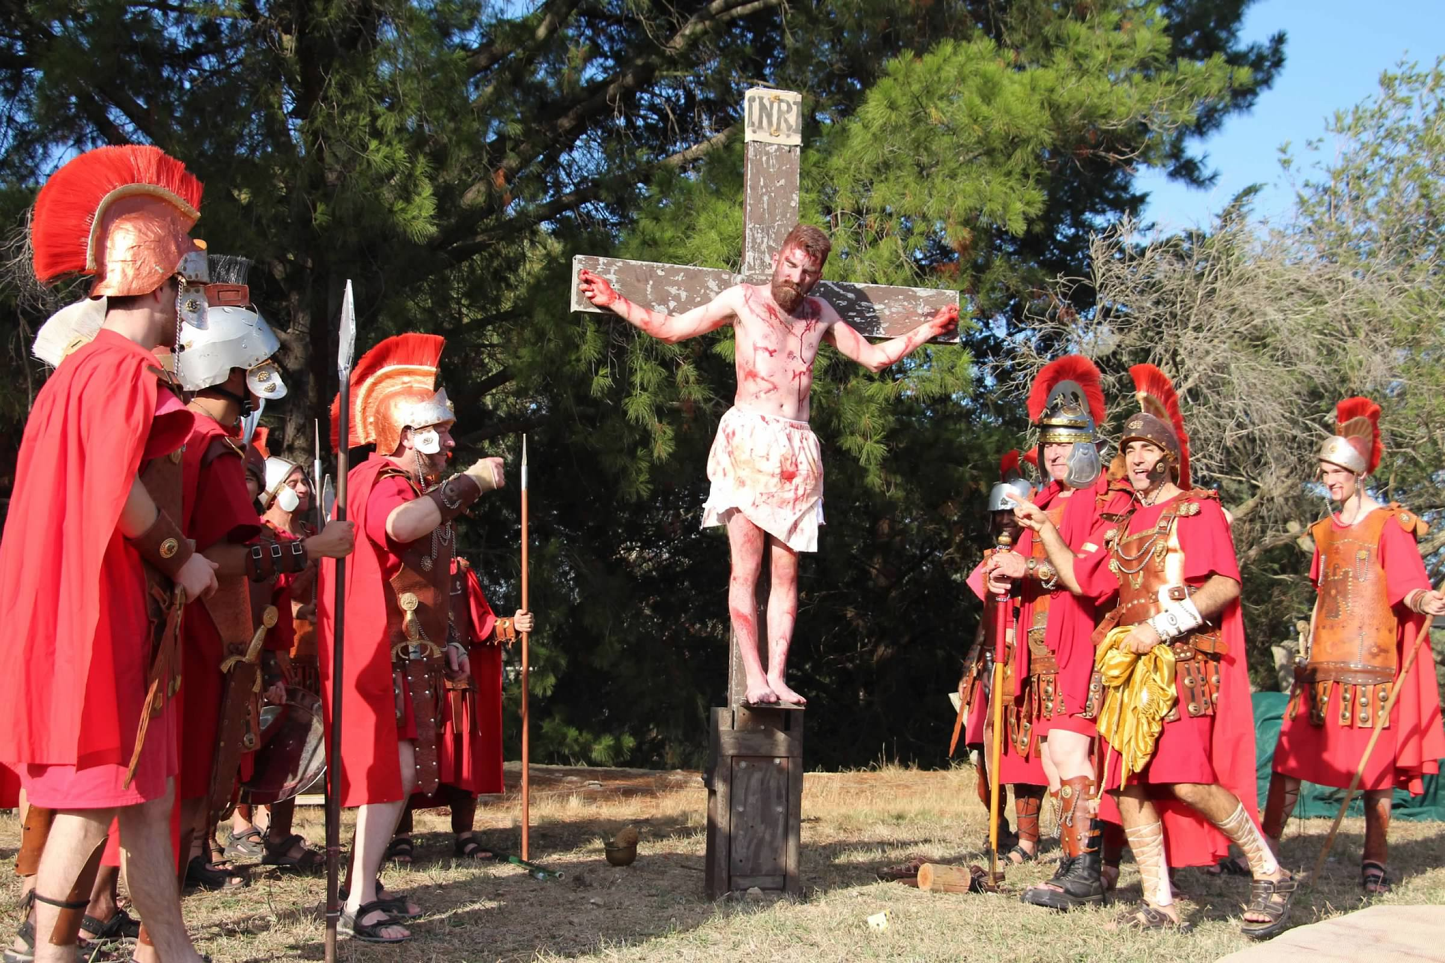

Recruiting volunteer cast members and backstage personnel for the 2025 season is underway. Positions are still available for cast members, including assistants for staging, props, wardrobe, makeup, microphones, etc.
Men and women are also required for the role of Roman Soldiers.
The Play is performed in front of a large audience.
All rehearsals and performances will take place on the grounds of the Catholic Regional College, 380 Sydenham Rd Sydenham Vic.
The cast will comprise of approximately 60 actors and crew and the Play will be performed on;-
Palm Sunday 13th April 2025 starting at 1:30 pm and on
Good Friday 18th April 2025 starting at 10:00 am.
No acting experience is necessary for any of the vacant roles.
Rehearsals take place each Sunday leading up to Easter. These start with a light lunch at 12:00noon. There will also be an afternoon tea break.
Only 4 rehearsals remaining.
For any enquiries, please call the Manager, Gino Gammaldi, on 0422 662 451 .
For more information visit our website at www.melbournepassionplay.com.au

